Creating a Scatter Plot
Step 1: Break your data into two groups and then plot them on an x, y axis.
Ten statistics students have taken the first exam. Below you will find the test score on the first exam and the student's current homework score. The maximum possible score on the test was 100 points and the maximum possible score on homework is 50 points.
Step 2: Create a scatterplot for the following scores. Graph the following points on the axis below. Do not connect the dots after plotting the points.
Student Test Score (X) Homework Score (Y)
Robert 61 35
Thomas 95 50
Mark 44 5
Wanda 93 50
Judy 63 15
Haydn 80 34
Barbara 62 16
Karen 95 50
Marilyn 65 7
Phil 88 38
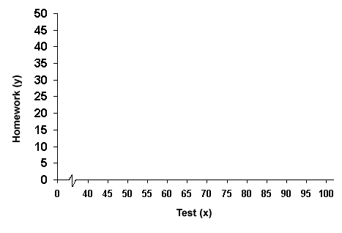

Making a Box and Whisker Plot

It was the first day of spring and the sun was shining in Sparks. Mrs. Ward decided to forgo teaching Algebra that day and instead took her class out to the football field to teach them how to throw the Shot Put. Out of her class of 28 students, only 13 were brave enough to attempt throwing the shot put. Considering it was the students’ first attempt at the shot put, they did quite well, their distances were:
6, 20, 18, 6, 11, 12, 12, 5, 14, 19, 8, 12, 21

Making a Box and Whisker Plot and finding the Five-Number-Summary
Step 1: Order the data from lowest to highest value
The minimum value is: _______ (smallest number in data set)
The maximum value is: _______ (biggest number in data set)
Step 2: The median value is the number in the middle of the data set.
The median value is: _______
What fraction of the values is greater than the median? ________
What fraction of the values is less than the median? __________
Step 3: Find the first quartile Q₁
The first quartile is the middle of the first half of the data.
Q₁ is: ______
Step 4: Find the third quartile, Q₃
The third quartile is the middle of the second half of the data. Q₃
Q₃ is: _______
Use these values to fill in the chart below

Step 5: Five Number Summary and Graph
Minimum Value: _________
Maximum Value: _________
Median, Q₂: ____________
First Quartile, Q₁: ________
Third Quartile, Q₃: ________
Box
Whisker
Whisker

Minimum Value
Median, Q₂
Q₃
Maximum
Value

Q₁

Try it yourself: Use the data to make your own box and whisker plot. Create the 5 number summary first and then plot.

The last 10 World Records for the Men’s Shot Put in meters are:
22.00, 22.15, 22.22, 22.62, 22.69, 22.72, 22.84, 22.91, 23.06, 23.12

Creating a Histogram
Consider the set {3, 11, 12, 19, 22, 23, 24, 25, 27, 29, 35, 36, 37, 45, 49}. A graph which shows how many ones, how many twos, how many threes, etc. would be meaningless. Instead, we bin the data into convenient ranges.
Step 1: You need to choose the data range. In this case, with a bin width of 10, we can easily group the data as below in a frequency table.
Step 2: Create a frequency table. The frequency is how many times a number occurs in the data range. For example, in the data range 10-20, we have numbers 11, 12, and 19, so the frequency is 3.
Step 3: After you create the table you make a graph for the data.

Data Range | Frequency
0-10 | 1
10-20 | 3
20-30 | 6
30-40 | 4
40-50 | 2
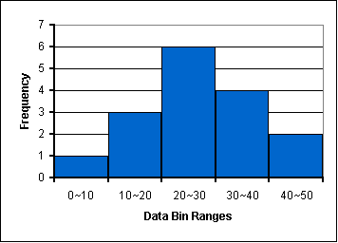

Try it yourself : Create a frequency table and a histogram for the following set of data.
21, 35, 36, 38, 40, 40, 41, 42, 45, 46, 46, 48, 49, 50, 46, 48, 49, 50, 55, 56

Remember to decide on a bin size and then create your frequency table. After you have your table then graph.

Creating a Pie Chart

A family's weekly expenditure on its house mortgage, food and fuel is as follows:
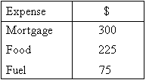
Draw a pie chart to display the information.
Step 1: find the total weekly expenditure by adding $300+$225+$75=$600
Step 2: Find what percentage of the total expenditure each item equals.
Percentage of weekly expenditure on:
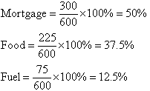
Step 3: To draw a pie chart, divide the circle into 100 percentage parts. Then allocate the number of percentage parts required for each item.
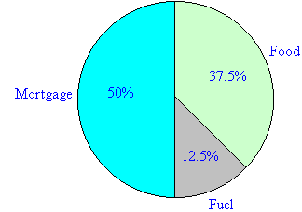
Try it yourself : Create a pie chart for the following set of data.

Sports | # of People in Sports
Football | 24
Baseball | 28
Basketball | 12
Golf | 8

