Standard Deviation for Samples

Standard Deviation: The measure of how spread out your data are. It shows how much variation exists from the average (mean).

How to Calculate Standard Deviation:
Step 1: Compute the mean for the data set
Step 2: Compute the deviation by subtracting the mean from each data point
Step 3: Square each deviation
Step 4: Add up the squared deviations
Step 5: Divide the squared deviation total by one less than the number of data points
Step 6: Take the square root of the number

Example:
Find the standard deviation for the data set: 1, 3, 4, 6, 9, 19

Step 1: Find the mean.
(1+3+4+6+9+19)/6 = 42/6 = 7 Mean = 7
Step 2: Compute deviations.
Data point-mean
1-7 = -6
3-7 = -4
4-7 = -3
6-7 = -1
9-7 = 2
19-7 = 12
Step 3: Square each deviation.
(-6)² = 36
(-4)² = 16
(-3)² = 9
(-1)² = 1
(2)² = 4
(12)² = 144
Step 4: Add the squared deviations.
36+16+9+1+4+144 = 210
Step 5: Divide the squared deviation total by one less than the number of data points
One less = 5
210/5 = 42
Step 6: Take the square root of the number.
$\sqrt{42}=6.48$

So the standard deviation for this data set is 6.48.

Now it is your turn to try.

Find the standard deviation of each data set below.

1) 1, 2, 3, 4, 5

2) 4, 2, 5, 6, 8, 3

3) 73, 58, 67, 93, 33, 18, 147

4) 6, 12, 25, 40, 40, 48, 60, 75

Normal Distribution

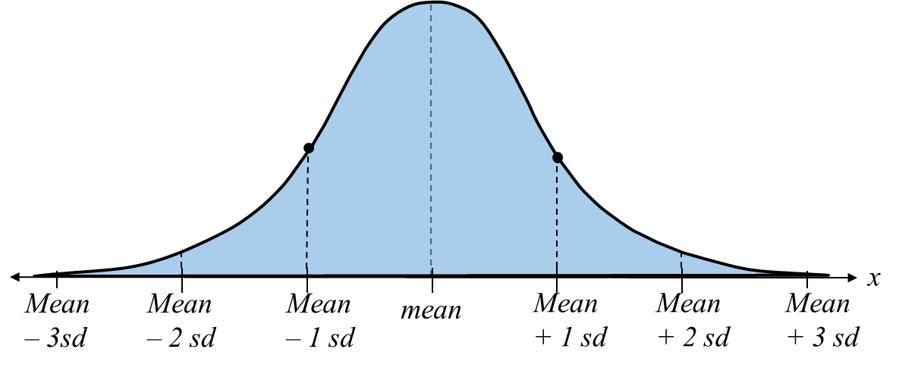

For data set #3 from above, create a normal curve graph.
You need to graph the mean and then three standard deviations on your graph. Use your mean from #3 above and the standard deviation in order to graph the normal curve.

